Aequs EduTrack — Project Timeline

Development History & Milestone Tracker

Project | Aequs EduTrack
Start Date | August 12, 2026
Latest Commit | August 27, 2026
Duration | 16 calendar days (7 active dev days)
Total Commits | 30
Contributors | 2 (salonidalvi-008, Code-Cool-2006)

Development Gantt Chart

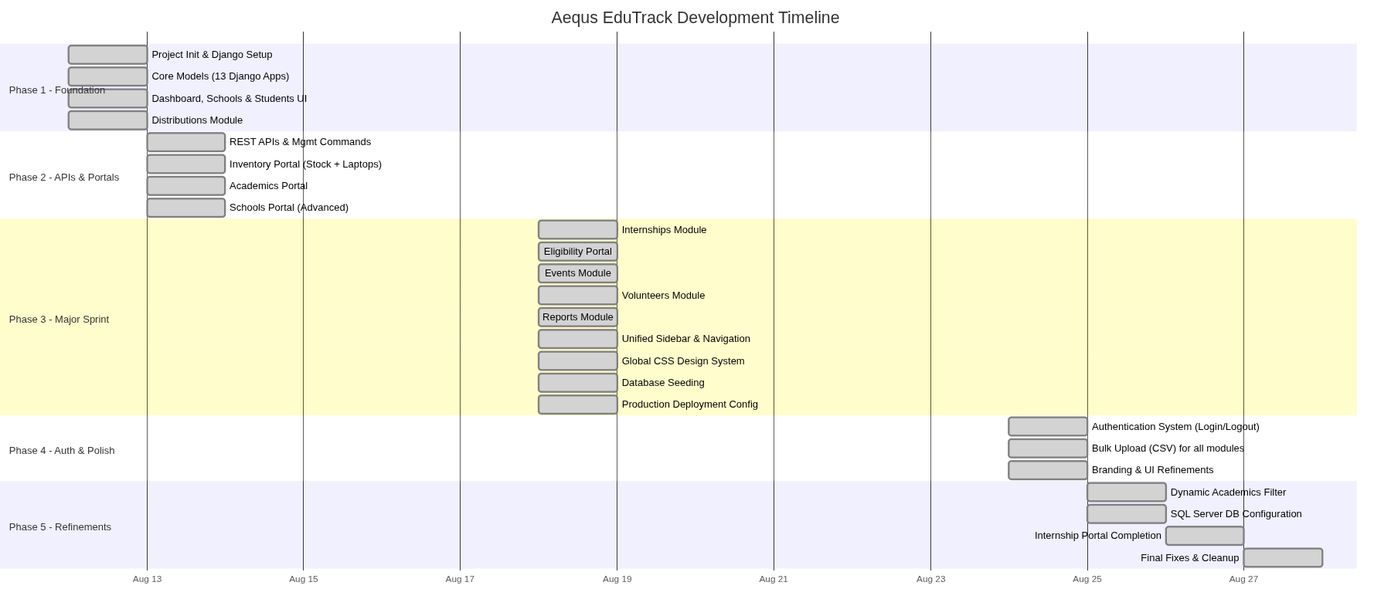

Day-by-Day Development Log

📅 Day 1 — August 12, 2026 (Tuesday)
Phase: Project Foundation

Time | Author | Milestone
11:03 AM | salonidalvi-008 | Initial project creation — Django project scaffolding with 13 app modules
3:43 PM | salonidalvi-008 | Distributions module — Distribution forms, templates, and URL routing

Modules Created:
- academics, accounts, audit, backend, distributions, documents, donations
- eligibility, events, expense_management, internships, inventory
- notifications, reports, schools, students, volunteers

Key Deliverables:
- Django project with custom User model (5 roles: Super Admin, Admin, Accountant, Volunteer, Event Coordinator)
- School model with UDISE codes, headmaster info, and district/taluk/village hierarchy
- Student model with admission number, parent/guardian details, and status tracking
- AcademicRecord model linked to students with marks, percentage, and promotion tracking
- EligibilityRecord model with 5 benefit types (Books, Workbooks, Study Kit, Laptop, Internship)
- Laptop and LaptopAssignment models for asset tracking
- Dashboard template with KPI summary cards
- Student list, detail, and add forms
- School list and form templates
- Distribution form and list templates

📅 Day 2 — August 13, 2026 (Wednesday)
Phase: APIs & Portal Enhancement

Time | Author | Milestone
12:18 PM | Code-Cool-2006 | Modular REST APIs, management commands, inventory & academic portals

Key Deliverables:
- InventoryItem and StockTransaction models for general warehouse management
- Full Inventory Portal template with stock tracking
- Full Academics Portal template with advanced UI
- Schools Portal redesign with enhanced management view
- Management commands: seed_schools, seed_inventory, seed_academics
- Distribution services layer with Study Kit support (StudyKit, StudyKitItem)
- School model extended with affiliation and established_date

📅 Day 3 — August 18, 2026 (Monday)
Phase: Major Feature Sprint (15 commits in a single day)

This was the most intensive development day, with both contributors working in parallel and merging features.

Time | Author | Milestone
9:26 AM | Code-Cool-2006 | Internship module — InternshipProgram, InternshipPlacement, InternshipMilestone models, portal template, eligibility management services
9:45 AM | salonidalvi-008 | Core EduTrack features — Events, Volunteers (with VolunteerActivity & EventParticipation), Reports, academic forms, eligibility views
9:56 AM | salonidalvi-008 | Git housekeeping — .gitignore for temp/backup files
10:49 AM | Code-Cool-2006 | Branch merge — Resolved merge conflicts between parallel work streams
10:53 AM | Code-Cool-2006 | Fix HTML tag duplication from merge
10:54 AM | Code-Cool-2006 | Migration merge files for distributions & inventory
11:02 AM | Code-Cool-2006 | Navigation fix — Connected Events, Volunteers, Reports across all sidebar portals
11:27 AM | Code-Cool-2006 | Sidebar v1 — Modern dark sidebar with Lucide icons on dashboard & eligibility
11:46 AM | Code-Cool-2006 | Sidebar v2 — Unified dark Lucide sidebar across all pages
11:55 AM | Code-Cool-2006 | Global CSS — Unified design system (topbar, tables, buttons, cards)
11:58 AM | Code-Cool-2006 | Compact density standardization for Programs, Students, Academics
12:01 PM | Code-Cool-2006 | Font cleanup — removed inflated Outfit fonts, locked compact scale
12:07 PM | Code-Cool-2006 | Fixed sidebar to 256px, removed conflicting styles
12:21 PM | Code-Cool-2006 | Sidebar v3 — Transformed to light/white theme with Aequs branding
12:25 PM | Code-Cool-2006 | Dashboard upgrade — shadcn-style stat cards and tables with Lucide icons
12:32 PM | Code-Cool-2006 | Database seed script — Full seed_database.py with realistic government school data from Belagavi district
12:35 PM | Code-Cool-2006 | Student filter bar — Multi-attribute filter (search, school, class, gender, status)
12:47 PM | Code-Cool-2006 | Production deployment — Gunicorn, Whitenoise, PostgreSQL, Docker, Render
1:58 PM | salonidalvi-008 | Restored local distribution and eligibility changes

📅 Day 4 — August 24, 2026 (Sunday)
Phase: Authentication & Bulk Operations

Time | Author | Milestone
9:16 AM | salonidalvi-008 | Bulk upload system — CSV upload templates for Students, Schools, Academics, Inventory
11:04 AM | Code-Cool-2006 | Authentication system — Login/Logout views, login template with Aequs branding, session management
11:32 AM | salonidalvi-008 | Distribution & eligibility handling improvements

Key Deliverables:
- Login page with blurred Aequs SEZ background, glassmorphism card design
- Login/logout views with authentication checks
- Dashboard protected with is_authenticated guard
- Bulk upload templates (CSV) for Students, Schools, Academics, and Inventory
- Portal repair and icon fix utility scripts

📅 Day 5 — August 25, 2026 (Monday)
Phase: Academic Enhancements

Time | Author | Milestone
2:16 PM | salonidalvi-008 | Dynamic academic filter — Class filter with CourseMaster model
2:29 PM | salonidalvi-008 | SQL Server configuration — Database backend switched to MSSQL
2:39 PM | salonidalvi-008 | Academic form template and migration refinements

📅 Day 6 — August 26, 2026 (Tuesday)
Phase: Internship Portal Completion

Time | Author | Milestone
2:18 PM | salonidalvi-008 | Complete internship management portal — Full-featured portal with program management, placement tracking, milestone logging, and performance evaluation

📅 Day 7 — August 27, 2026 (Wednesday)
Phase: Final Fixes

Time | Author | Milestone
9:26 AM | Code-Cool-2006 | Final cleanup and temporary fixes

Module Evolution Timeline

The following diagram shows when each module was first introduced and when it received major enhancements:

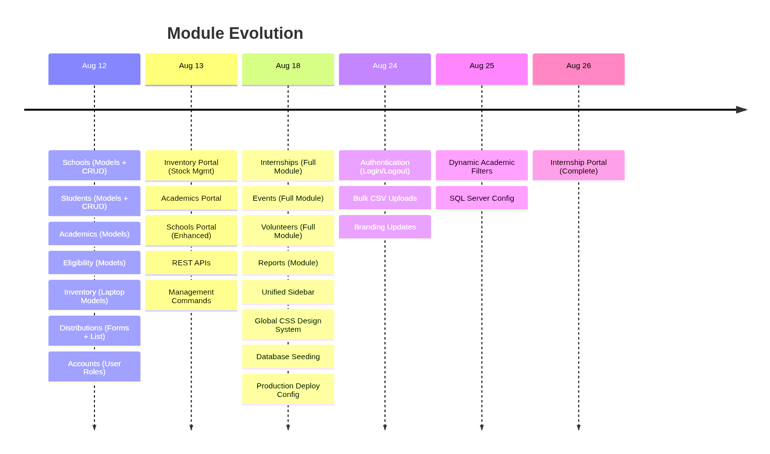

Contributor Analysis

salonidalvi-008 — 11 commits

Area | Contributions
Project Setup | Initial Django project scaffolding, 13 app modules, core models
Distributions | Distribution forms, templates, views, eligibility handling
Core Features | Events, Volunteers, Reports, academic forms, school forms
Bulk Operations | CSV upload system for all modules
Database | SQL Server configuration, academic migrations
Internships | Completed the internship management portal

Code-Cool-2006 — 21 commits

Area | Contributions
APIs & Services | REST APIs, management commands, service layers
Portals | Inventory, Academics, Schools, Eligibility, and Internships portals
UI/UX Design | Sidebar (3 iterations), global CSS, dashboard shadcn-style upgrade
Authentication | Login/logout system with branded UI
DevOps | Production deployment (Gunicorn, Whitenoise, PostgreSQL, Docker, Render)
Data | Seed database script with realistic Belagavi district data
Quality | Merge conflict resolution, navigation fixes, font/layout cleanup

Development Statistics

Metric | Value
Total Commits | 30
Active Development Days | 7 out of 16 calendar days
Peak Day | Aug 18 — 15 commits in a single day
Contributors | 2
Django Apps Created | 15+
Database Models | 17
HTML Templates | 35+
Portal Pages | 7 (Schools, Students, Academics, Eligibility, Inventory, Internships, Distributions)
Sidebar Redesigns | 3 iterations (dark → dark unified → light/white Aequs theme)
Deployment Targets | Docker, Render, Gunicorn + Whitenoise
Database Support | SQLite (dev), PostgreSQL (prod), SQL Server (enterprise)

Technology Stack

Layer | Technology
Backend | Python 3.x, Django
Frontend | Django Templates (HTML), Vanilla CSS, JavaScript
Icons | Lucide Icons (CDN)
Fonts | Inter, Montserrat (Google Fonts)
Database | SQLite / PostgreSQL / SQL Server
Static Files | Whitenoise
WSGI Server | Gunicorn
Containerization | Docker
Hosting | Render

Development Phases Summary

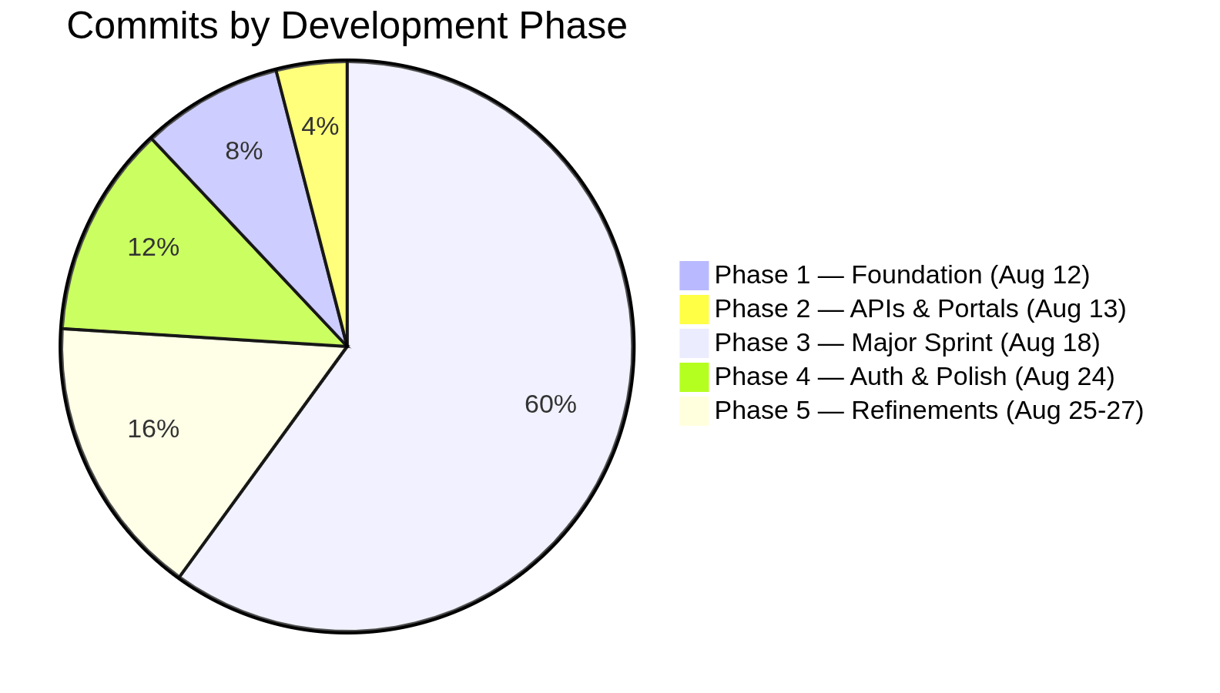

Phase | Dates | Focus | Commits
Phase 1 | Aug 12 | Project foundation — Django setup, core models, basic CRUD | 2
Phase 2 | Aug 13 | REST APIs, management commands, portal UIs | 1
Phase 3 | Aug 18 | Major sprint — 5 new modules, UI overhaul, deployment config | 15
Phase 4 | Aug 24 | Authentication, bulk uploads, branding | 3
Phase 5 | Aug 25–27 | Academic filters, database config, internship portal completion | 4

Timeline generated from git commit history on August 31, 2026.
© 2026 Aequs Foundation. All rights reserved.

